Key point:
AI, Cs, Sovereignty
- Sovereignty & strategic autonomy in the digital age is facing challenges.
  - 3 approaches + the 4th : go alone.
- Risk management approach
  - Identify, protect, detect, defend, recover.
  - Risk mgt approaches: Monitoring; big data-based threat detection; real-time response; recovery.
    - AI noteworthy information only helps CERT && big business values.
  - Ethical challenges:
    - Monitoring: intrusive & coercive
    - Sense of losing control of their own information
    - Not transparent
    - Transfer the blame to system
  - Ethical issues with AI & Cs:
    - erosion of individual autonomy,
    - unfair allocation of liability
    - fallacy of human in the loop
    - contestable ethics of mass surveillance and of trading off individual casualties versus collective protection
  - Risk mgt & residual risks:
    - Financially: cyber insurance
    - Political & sovereignty? How many lives cost?
      - Cyber-defensive strategy cut down electricity put lives in danger
    - System never fully protected. Intentional holes.
      - Kill-switch; systematic leakage hidden.
  - norms & values:
    - national:
      - cyber resilience; industry, tech skills; cyber defense; global cyberspace; cyber crime
    - international: Norms, principles, rules, confidence building measures (CBM)
      - open info & transparency
      - compatible governance
      - restraint & stability/mutual responsiveness
    - concrete norm CBM
      - do not harm
      - transparency CBM: do not deceive
        - Info exchange on cyber threats
        - Joint cyber exercise
        - Mutual software code inspection
      - Compatible governance CBM: to be fair, equitable and inclusive
        - Health sector, WHO, global industry, civil society, compare notes
      - In practice: hard. Eg: Child abuse, awareness raising, law enforcement, national strategy development.
      - CBM works on credible guarantee of effectiveness.
        - E.g. Huawei, code inspection
        - Frequent updating
        - Effectiveness of code control: intellectual property & transparency
  - Conclude: most followed, questions on ethics.
- Strategic partnership approach
  - AI: component for security
  - Securing AI: prevent hacking
  - Weaponized AI
  - Strategic partnership: like-minded
    - E.g. human rights; trade barrier; strategies trade geopolitics
    - Debate: human rights or “strategic ethics”?
    - Degree of share or pooled sovereignty?
  - Weaponized AI.
- Global common good approach
  - How much & what is the way
  - Flaws: lacking security-by-design & privacy-by-design & autonomy by design
    - AI, blockchain, encryption fix it
  - Code is law ? law is code?
    - AI: open source, distributed control. Eg. Domain system.
  - Global common good: not state centric. Enables state to focus on state interest rather than common good.
  - Weakness:
    - International governance not well-equipped.
    - Vulnerable to state-centric behavior.
  - Basis: UN initiatives
    - More on risk mgt.
    - Weakness: only in norms & principle levels, not in CBM levels.
  - Conclusion: deserve more attentions.
- Policy recommendations
  - Risk mgt & resilience
    - International norms & values do not harm
    - Practical: whole AI chain pre: data capture; AI processing; post-AI algorithnm
    - AI-enabled cyber exercise
    - interoperability, standardization, certification and promoting open data cyber resilience AI threat analysis fed by big data
    - legislation
  - strategic partnerships
    - seek internationalizing global dimension.
    - Weaponized AI
    - Trade policy
  - Global common good
    - Private-public collaboration
    - Intergovernmental work
    - Personal data protection
- Conclusion & perspectives
  - Conceptual framework?
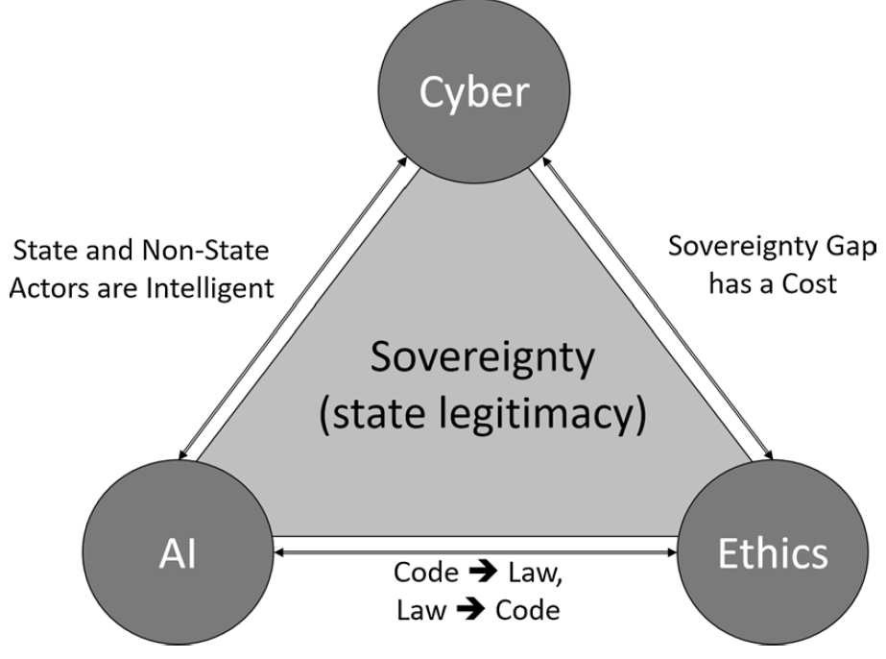

1. Identify and discuss the ethical challenges in AI enabled cyber risk management that the author had raised. Discuss two additional and different ethical or other governance issues you can find in cybersecurity literature.

    - Monitoring: intrusive & coercive
    - Sense of losing control of their own information
    - Not transparent
    - Transfer the blame to system

    - erosion of individual autonomy,
    - unfair allocation of liability
    - fallacy of human in the loop
    - contestable ethics of mass surveillance and of trading off individual casualties versus collective protection

2. The author explained residual risks, from both financial and non-financial perspectives. Research another case study that is different from the one used by the author and use it to explain your own understanding of the residual risks of AI enabled cyber threats.

- Risk mgt & residual risks:
    - Financially: cyber insurance
    - Non-financial: Political & sovereignty? How many lives cost?
      - Cyber-defensive strategy cut down electricity put lives in danger
    - System never fully protected. Intentional holes.
      - Kill-switch; systematic leakage hidden.

3. The author discusses three solution options for addressing the ethical challenges in cybersecurity: taking a national, preferably a government lead risk management approach; adopting a strategic partnership approach that involves regional commitment of business and government stakeholders from countries; and considering a global “common good” approach that depends on setting up an international governance body, such as the United Nations, in managing cyber risks.
Summarise these 3 approaches in your own words and supported by a consolidating visual diagram of your explanations. For each of the approaches, you need to include at least 1 citation to strengthen the insights of each summary.

1) definition
2) How they use AI & Cs, effectiveness
3) weakness & unrealistic
4) how to deal with it
4) one more case

Virtual graph.

4. The author highlights that cybersecurity and ethics conflict because of the differences of nations’ rights to sovereignty (in terms of countries wanting to assert their sovereign power and values on each other through cyber activities). This conflict affects the protection of human rights, nations’ societal values and ways of life and sometimes territorial boundaries.
Research 2 case studies and use them as illustrating examples to explain the non-financial costs of sovereignty conflicts prevailing in cyber activities among countries.

Non-financial costs of sovereignty conflict among countries.

5. What additional insights can you abstract and conclude from your answers to the implied questions that underpin the above inquiry instructions?

